GSE_shell

Version 1.1 beta

Quick manual

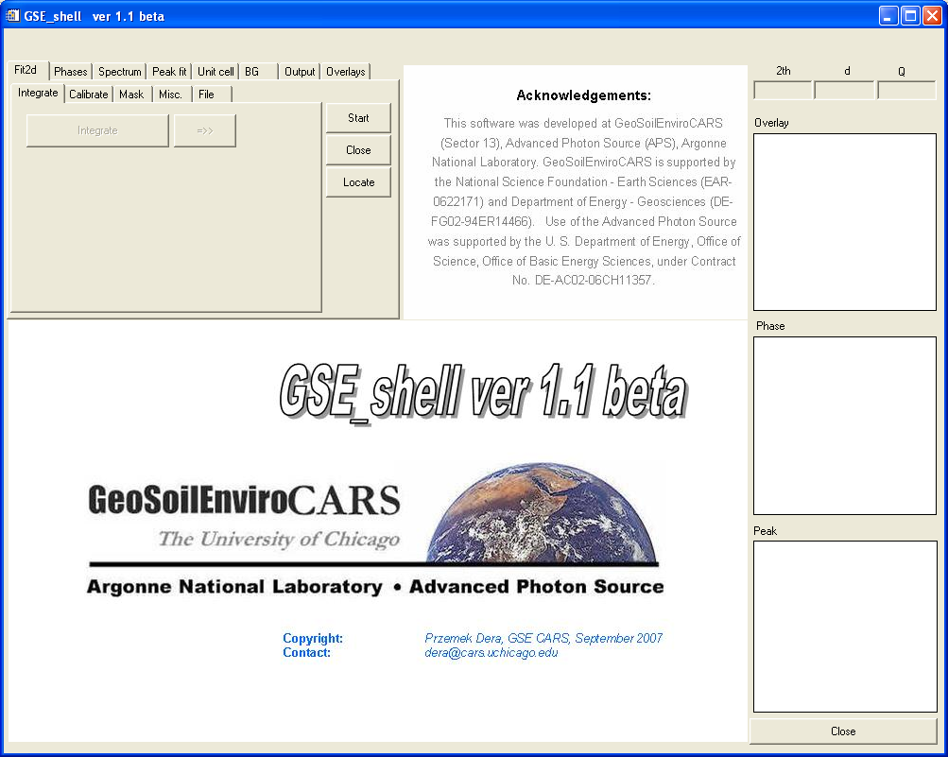

Przemek Dera

dera@cars.uchicago.edu
GeoSoilEnviroCARS, University of Chicago
September 26, 2007

Table of contents

Table of contents 2
Introduction 3
Installation and setup 3
Opening an image 5
Browsing through a series of images 5
Calibration 5
Integration 5
Working with existing chi files 6
Zooming the displayed spectrum range 6
Using Mask files 6
Background fitting and subtraction 7
Overlaying multiple powder patterns 7
JCPDS references 8
Adjusting pressure 8
Peak fitting 8
Lattice parameter refinement 9
Final disclaimer 9

Introduction

GSE_shell is a GUI (Graphical User Interface) driven program developed at GeoSoilEnviro CARS to help researchers collecting x-ray diffraction data at the synchrotron in quick preliminary evaluation and simple analysis of their experimental results. GSE_shell allows to remotely control the integration of diffraction images by Fit2d program, helps to quickly identify the phases present in the sample (using JCPDS card library), and allows for comparison of patterns collected at different conditions.

It should be emphasized that GSE_shell is not intended as a tool for performing final analysis of the data.

Installation and setup

The installation package is this manual and a .zip file which contains all the files needed to run GSE_shell except for the fit2d executable, which should be obtained from the author of fit2d, Andy Hammersley. The zip file contains the following files:

acknowledgements.jpg
final_gsehead1.jpg
threshold.mac
Calibrate.mac
Mask.mac
GSE_shell.sav
GSE_shell_setup.txt

System requirements:

- You have to have IDL Virtual Machine installed to run the .sav file (main application file).
- IDL version 6.4 or newer is required. The sav file will not work with ver. 6.3 and older.
- GSE_shell was developed to work with fit2d V12.077 or newer. It may work with older versions by results are not guaranteed.
- GSE_shell was only tested using Windows XP professional. It may work with other operating systems but results are not guaranteed.
- To run GSE_shell conveniently you will need a monitor with minimum resolution of 1000x800 pixels.
- You will need a mouse with 3 buttons

To install the program:
  - Create a new directory for the program.
  - Uncompress the files contained in the distribution .zip file into that directory.
  - Modify the content of “GSE_shell_setup.txt” file. The content of the distribution file is as follows:

fit2d executable location ; C:\Soft\fit2dtest\fit2d.exe
jspds card library location ; T:\dac_user\JCPDS\dac_user_jcpds
calibrate script location ; P:\dera\fit2dtest\calibrate.mac
mask script location ; P:\dera\fit2dtest\mask.mac
data directory ; T:\dac_user\2007\BMD_2007-2\
destination directory ; C:\GSE_shell\

The directory and file locations have to be modified to reflect actual locations of files and directories on your computer, as described at the beginning of each line. DO NOT change the text before the semicolon (;) sign. Place one space after the semicolon, before the names of directories/file locations, as in the distribution file.

  - Select the “GSE_shell.sav” file with mouse. Right click and select “Properties”. Make sure that the field “Open with” in “General” tab is set to IDL VM, and the icon looks like this:

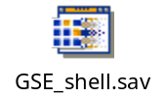

Now you should be ready to go. Double click on “GSE_shell.sav”. An IDL window like the one below should pop up. Fit2d control is optional so fit2d will not start automatically (as was the case in ver. 1.0).

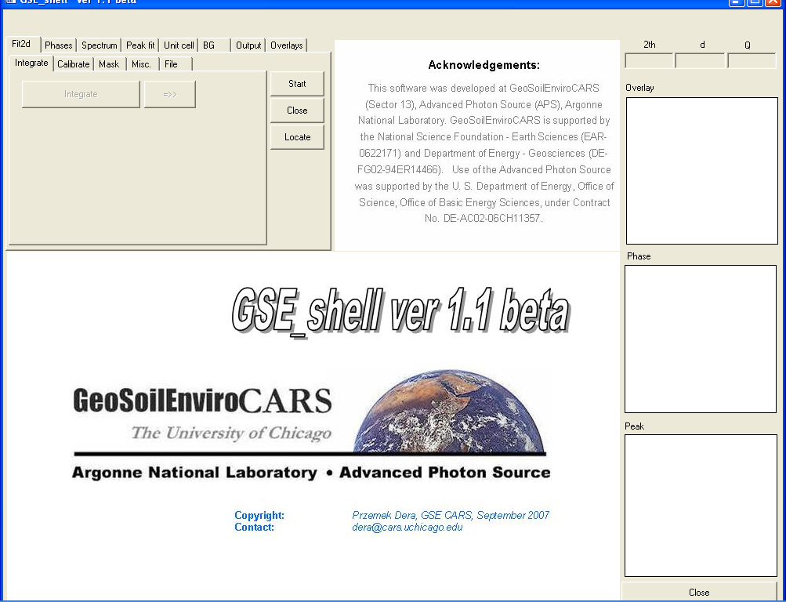

Opening an image

GSE_shell offer a possibility to communicates with an open session of fit2d through command line interface (there is no possibility to graphically interact with this session). To start the fit2d session go to the fit2d tab and click the "Start" button. If the location of the fit2d executable specified in the settings file is correct, you should see a session of fit2d open. If this does not happen, you can locate the fit2d executable using a browser, after pushing the "locate" button. New location will be saved in the settings file. Fit2d session can be closed by pushing the "Close" button. Every time you push a button in GSE_shell that is supposed to trigger some response in fit2d, a string command will be sent to command line. To open an image go to “File” tab, and click the “...” button. After selecting the image file (‘tif’ and ‘MAR3450’ formats available) the image should show in the fit2d window. The directory from which you read the image will be searched for images with similar file names that form a series (sequence numbers being the last three characters before the full stop separating filename from the extension). The range of images available within the series will be displayed in text boxes at the bottom of the menu area.

Browsing through a series of images

The name of the file will be displayed in the text field above the “Open image” button. If there is a series of images that have sequence numbers being the last three characters of the file name (e.g. filename001.tif, filename002.tif) you can browse through the series using the “<-” and “->” buttons the new images should appear in the fit2d window and the file name should be updated in the text field. While fit2d is on the program will automatically update the available image range within the file series every 2 seconds.

Calibration

For most calculations (e.g. integration) fit2d uses detector parameter calibration, which describes the pixel size, beam center pixel coordinates, sample-to-detector distance, etc. The detector calibration can be saved in a text file through GSE_shell. To perform a calibration with a diffraction image collected for a standard acceptable by fit2d go to the “Calibration’ tab, and click “Run calibration”. A second session of fit2d will open and your current image will be loaded. For this new session graphical interaction with fit2d is enabled. Perform calibration the normal way it is done in fit2d, REMEBER TO INTEGRATE THE IMAGE AT THE END, and EXIT THE ADDITIONAL SESSION of fit2d. New calibration parameters should now appear in the text fields of the “Calibration tab”. You can change the values in those fields, and pass them to fit2d by pressing “Set calibration”. You can read the current calibration from fit2d memory by pressing “Get calibration”. “Read calibration” and “Write calibration” are used for loading and saving the calibration parameters from and to an ASCII file on the disk.

Integration

Once calibration is available, the image in fit2d memory can be integrated. To do so go to the “Integrate” tab, and press the “Integrate” button. Fit2d will perform the required calculations and the integrated spectrum will be displayed first in fit2d, and then in the larger of the graphical windows of GSE_shell. The chi file is automatically saved by fit2d. At any time you can use the “save chi” button in the “File” tab. A series of images can be integrated automatically in sequence, using the same calibration, by pressing the “=>” button in the “Integrate” tab. It is possible to narrow down the range of images being processed to avoid integrating the whole long series. To do so change the values for the image series range using the editable text boxes at the bottom of menu section.

Automatic processing

Selecting the “Autoprocess new files” checkbox will make the program to check every 1 second for presence of new images belonging to the same series. If an image with a sequence number next to the previous series range end is found, the image is integrated using the currently loaded calibration. Once the new integrated spectrum is available, it is loaded to GSE_shell as primary spectrum.

Using Mask files

In GSE_shell it is possible to use masks to exclude certain regions of image from integration in the same manner it is done in fit2d. Go to the “Mask” tab (in Fit2d menu). To read in an existing fit2d mask click the “…” radio button. Pick the .msk file that you want to use and it will be loaded into fit2d (you will see the excluded regions marked red on it the fit2d window). The name of the mask file will be shown in the text field next to the button. To clear the mask click the radio button again the image will be re-displayed w/o red exclusion regions and the text field will be cleared. To create a new mask file for your image click the “Create mask” file. A new session of IDL will start and the current image will be loaded. You can define the exclusion regions the normal fit2d way and save the mask .msk file. After exiting the new session of fit2d use the “Use mask” radio button to load the newly created mask file. Clicking the “Modify existing” button will open an interactive session of fit2s with the current image loaded and the selected existing mask in the memory. It is also possible to use threshold (maximum) filter to mask all the pixels that exceed certain number of counts. To do that use the “Threshold button in the “Mask” tab and the text box above it.

Working with existing chi files

An alternative way to get access to integrated spectrum in GSE_shell is to read it from existing .chi file. This can be done using the “...” button in the “Spectrum“ tab of the main tab menu. The name of the chi file will be displayed in the text field above the “Open chi” button. If the current chi spectrum is a part of series of spectra that follow similar naming convention as for the images (i.e. the last three characters of the file name are the sequence number), the series can be browsed through, using the “<-” and “->” buttons, similarly like images.

Zooming the displayed spectrum range

In order to better see the details of the spectrum being analyzed it is possible to zoom in an out on certain regions of the spectrum. To do that click the right mouse button within the large graphical window area. A small context menu will appear next to the mouse cursor. Select the zoom option. Now use the left mouse button click (DO NOT depress the button and drag, just click once) to define one corner of the region of interest. Then move the cursor to the opposite corner of the region of interest and click the left button again. The spectrum in the large graphic window should be “zoomed”. You can revert to the original display range by clicking the middle mouse button. Clicking the right mouse button will exit the zooming mode. Leaving the area of the large graphics window with your mouse cursor should switch the zooming mode off. To unzoom after exiting the zoom mode click the right mouse button inside the large graphics window and select “Unzoom” .

Background fitting and subtraction

For the preliminary analysis and inspection of your diffraction data it is convenient to work with integrated patterns that have background removed. GSE_shell offers simple facility to fit and subtract background. You can access this facility by selecting the “Background” tab. By clicking the “Fit” button the background function will be modeled and overlaid with your spectrum. GSE_shell uses a simple cubic spline function to model the background. There are two “modes” of background fitting that can be selected using the check box next to the “Marigin” text box. If your spectrum has significant “shoulders” of two sides, chech Two parameters that can be controlled by the user are the sampling interval of the spline function and the tension parameter (see IDL manual for reference). It is also possible to save the background function as a chi file, by clicking on the “Save” button in the “Background” tab.

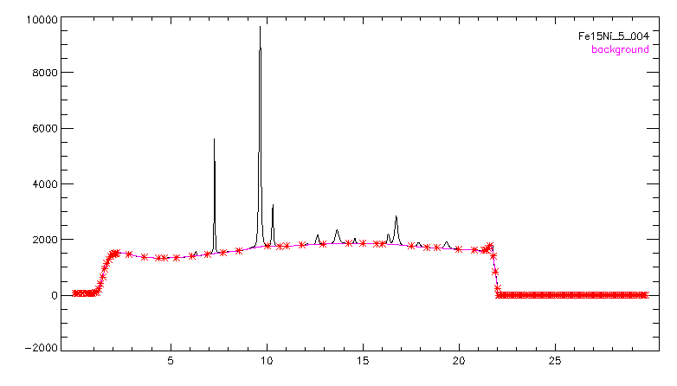

Overlaying multiple powder patterns

It is possible to overlay several (up to 10) integrated powder patterns. To add an overlay go to “File” tab and press the “Add overlay” button. The new pattern will be plotted over in the graphical window with a different color. The name of the overlaid file will be displayed in the list box next to the button. One can shift the overplot or scale it (multiply intensity by a scaling factor) with respect to the main spectrum by using the appropriate “+” and “-” buttons in the “File” tab, while the overlay file name is highlighted in the list box. Individual overlays can be removed by clicking the “Delete overlay” button when the overlay file name is highlighted in the list box. Button “Clear overlays” removes all the overplot spectra.
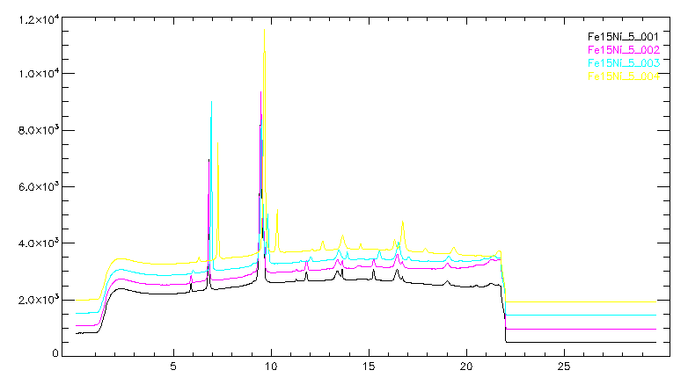

JCPDS references

GSE_shell allows comparing your experimental data with references from the crystallographic database (JCPDS cards). To load a reference, go to the “Phases” tab and click “Add phase” button. The file browser will take you to the directory specified in your “GSE_shell_setup.txt” file. Select the JCPDS card file that you want to input. Before loading the JCPDS card it is necessary to make sure that the correct calibration parameters were loaded (they contain wavelength, which is necessary to compute Bragg angles of reflections). The peak positions of your JCPDS reference will be displayed as vertical lines and will be overlaid with the spectrum, and the name of the JCPDS file will be added in the list box on the left side of the “Phases” tab. After adding a phase the peaks of this phase will be listed in the list box on the right side of the “Phases” tab. The lattice parameters and crystal system f the new phase will be displayed in the “Unit cell” tab. It is possible to load up to 3 JCPDS references. You can switch off a display of any reference using appropriate radio buttons in the “Phases” tab. Individual references can be deleted by highlighting the file name in the list box on the left side, and clicking the “Delete phase” button. “Clear phases” button allows removing all references.
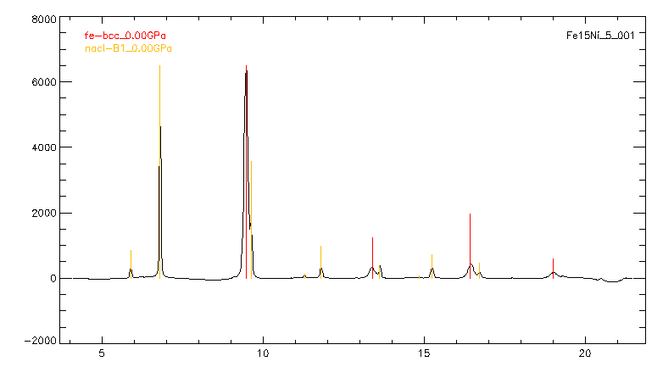

Adjusting pressure

The JCPDS cards contain information about the bulk modulus of the substance and its pressure derivative, thus peak positions of the reference phase can be calculated at different pressures. To change pressure for the reference you can type it in the text box, and click the “Recalc.” button. Peak position should be recalculated and new positions should be re-plotted on your spectrum. You can also change pressure by using the “<” and “>” buttons. The step for the change is specified in the text box in between these buttons.

Peak fitting

GSE_shell provides a very simple peak fitting facility which can allow you to refine lattice parameters and calculate an estimate of pressure from a diffraction standard. After loading a JCPDS reference, which will be used for the refinement you can click on the peaks in the right list box of the “Phases” tab. After you highlight a peak, a region of your spectrum surrounding that peak will be displayed in the small graphics window, together with a fitting curve corresponding to Gaussian 5-parameter function. The size of the displayed region is determined by the text field “Window” in the “Peak fit” tab. You can fit all the peaks corresponding to the given phase by clicking on the “Fit button” in the “Peak fit” tab. The results of the fitting will be displayed in the list box in the “Peak fit” tab. The columns of the displayed text contain:
- Calculated 2theta (JCPDS at given pressure),
- fitted 2theta, 2theta difference,
- fitted d-spacing,
- d-spacing difference
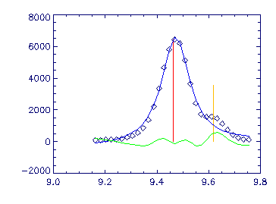

Results of peak fitting:

GAUSS_PROFILE function used

Excl | hkl | 2th_c | I_calc | 2th_m | d_m | I_m | FWHM | chi^2
1 1 1 1 5.886 13 5.895 3.252 19.2 0.067 343.17
1 2 0 0 6.798 100 6.804 2.817 295.2 0.064 143.59
1 2 2 0 9.619 55 10.077 1.904 -111772.9 0.986 0.27
1 3 1 1 11.285 2 11.299 1.699 4.7 0.083 111.94
1 2 2 2 11.788 15 11.807 1.626 39.4 0.104 25.23
1 4 0 0 13.620 6 13.638 1.408 9.6 0.058 20973.83
1 3 3 1 14.849 1 14.967 1.284 -883.9 1.933 0.03
1 4 2 0 15.237 11 15.254 1.260 32.1 0.113 19.22
1 4 2 2 16.701 7 16.723 1.150 2.9 0.047 372776.63

Results of unit cell parameter refinement:

a = 5.6332 0.0026
b = 5.6332 0.0000
c = 5.6332 0.0000
alpha = 90.0000 0.0000
beta = 90.0000 0.0000
gamma = 90.0000 0.0000

Lattice parameter refinement

Once peak profiles are refined it is possible to refine lattice parameters of the reference JCPDS phase with proper symmetry constraints. Go to the “Unit cell” tab, and click “Refine” button. The refined lattice parameters along with the estimated standard deviations will be displayed. You can change the symmetry constraints by selecting the desired crystal system from the droplist. At the end of refinement the value of pressure best fitting the observed peak positions will be displayed in the “phases” tab. Please, remember the pressure estimate is only good if you have proper K0 and K’ in the JCPDS card file.

Graphic output

Final disclaimer

The author of this program does not accept responsibility for any damage to your computer or your data that may result from the use of GSE_shell program.

If you encounter any problems with stability of the program, or find other bugs, please notify the author at dera@cars.uchicago.edu

